EXPT NO: 4 | Probabilistic Classification using Naïve Bayes  (Gaussian & Multinomial Naïve Bayes)
DATE: 13.02.2026

SCENARIO 1 – MULTINOMIAL NAÏVE BAYES

Problem Statement
Classify SMS messages as Spam or Ham (Not Spam)..

Dataset (Kaggle – Public)
https://www.kaggle.com/datasets/uciml/sms-spam-collection-dataset

Target Variable: Message Label (Spam / Ham)
Input Feature: SMS Text Messages

IN-LAB TASKS (Multinomial Naïve Bayes)
- Import required Python libraries.
- Load the SMS Spam dataset.
- Perform data preprocessing:
  - Text cleaning (lowercase, punctuation removal)
  - Stopword removal (optional)
- Convert text into numerical features using:
  - Count Vectorization / TF-IDF
- Encode target labels.
- Split dataset into training and testing sets.
- Train a Multinomial Naïve Bayes classifier.
- Predict message classes.
- Evaluate performance using:
  - Accuracy
  - Precision
  - Recall
  - F1 Score
- Analyze misclassified examples.
- Apply Laplace smoothing and observe impact.

Visualization
• Confusion Matrix
• Feature importance (Top words influencing spam classification)
• Word frequency comparison (Spam vs Ham)

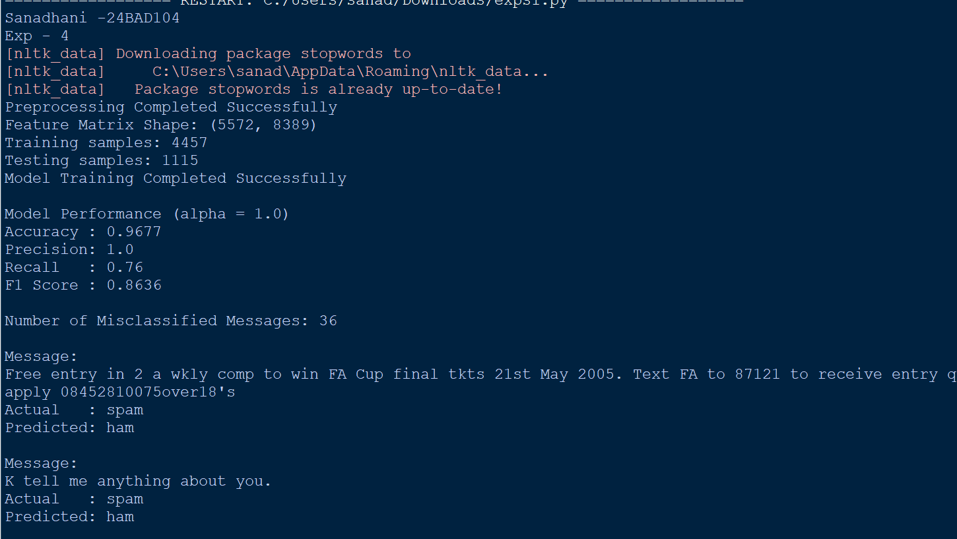
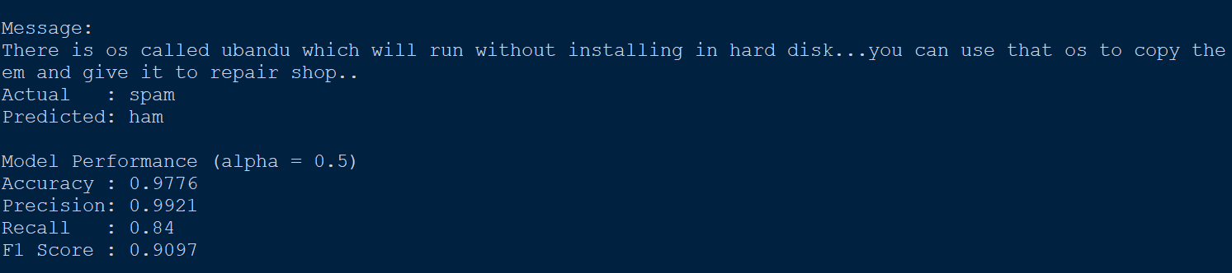

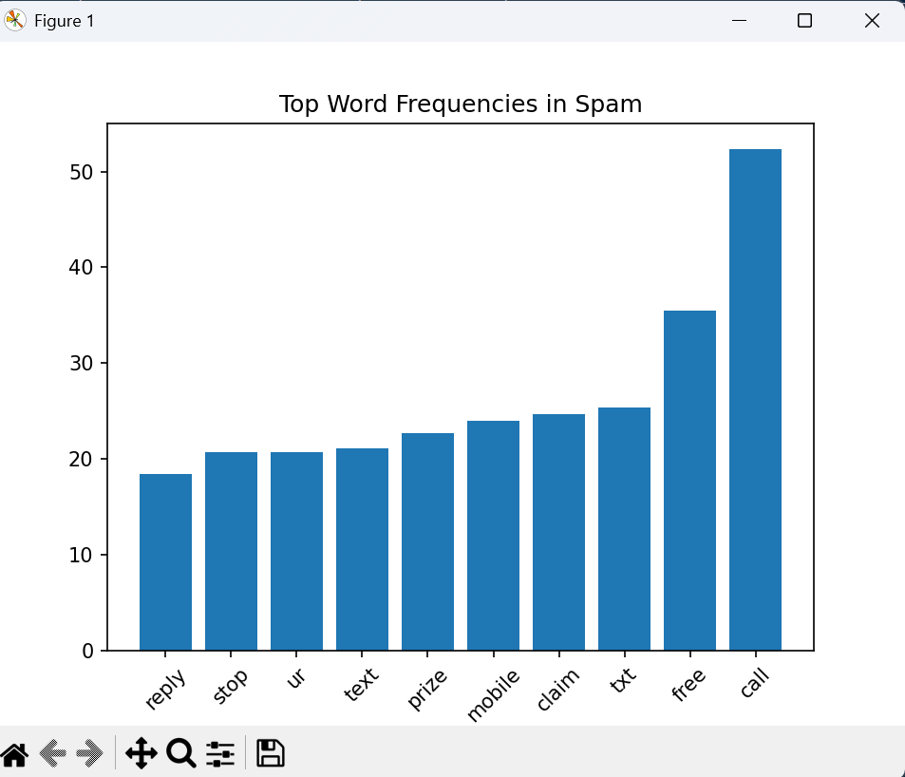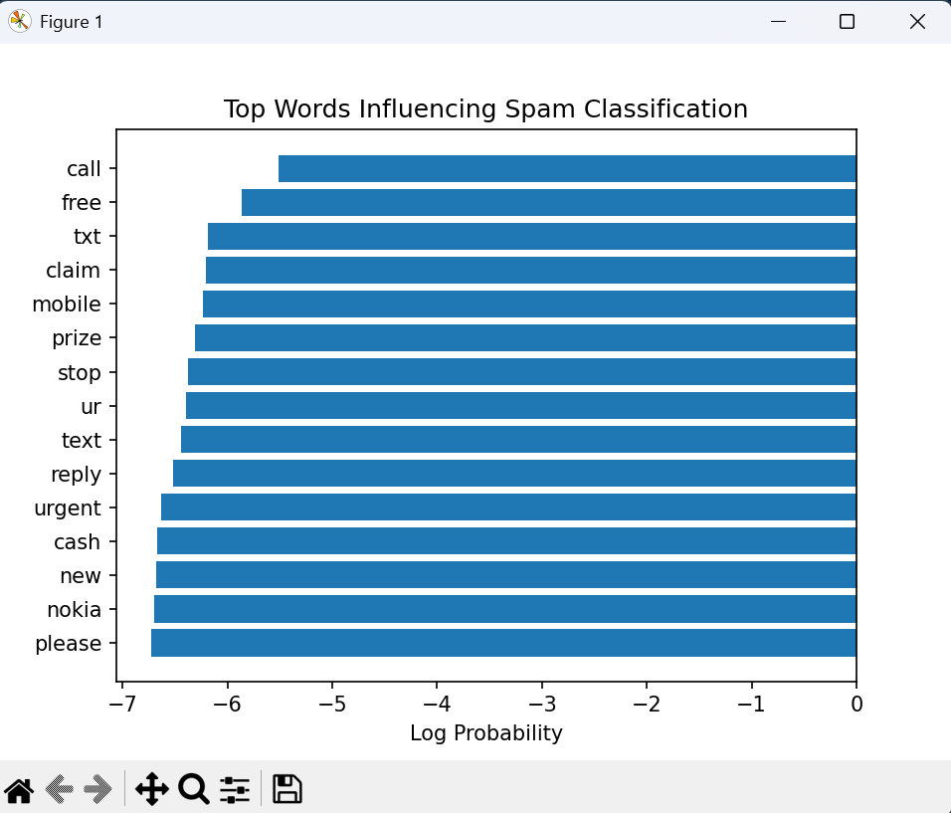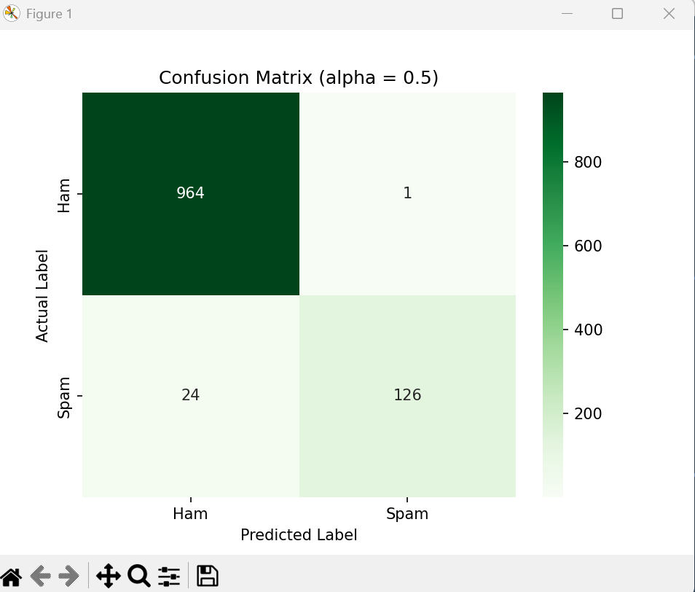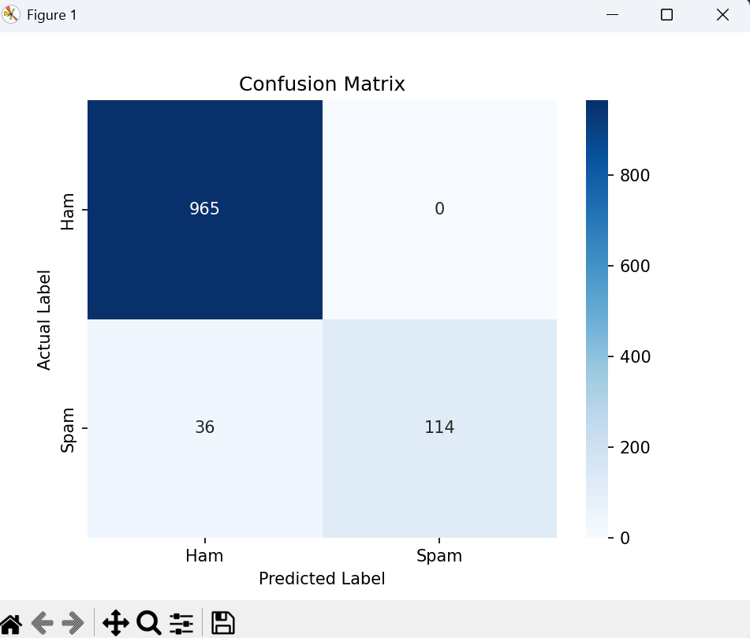

SCENARIO 2 – GAUSSIAN NAÏVE BAYES

Problem Statement
Classify flower species based on physical measurements.

Dataset (Public / Standard Dataset)
Iris Dataset (sklearn)

Target Variable: Flower Species
Input Features
• Sepal Length
• Sepal Width
• Petal Length
• Petal Width

IN-LAB TASKS (Gaussian Naïve Bayes)
- Import required Python libraries.
- Load the Iris dataset.
- Perform data inspection & preprocessing.
- Apply feature scaling.
- Split dataset into training and testing sets.
- Train a Gaussian Naïve Bayes classifier.
- Predict species labels.
- Evaluate performance using:
- Accuracy
- Precision / Recall / F1 Score
- Compare predictions with actual labels.
- Analyze class probabilities.
- Compare Gaussian NB with Logistic Regression (optional).

Visualization
• Decision Boundary Plot (using two features)
• Confusion Matrix
• Probability distribution plots

SUBMISSION REQUIREMENTS
- Python code (with student roll numbers)
- Screenshot of code
- Screenshot of outputs and graphs
- GitHub repository link

